CHM 1045

Worksheet Chapters 8 & 9

- What is the formal charge of N in the nitrate ion?
F.C. (N) = 5 – (0+1/2*8) = +1

- What is the molecular shape and the electron geometry of TeCl₄?
Valence e = 6 + 4*7 = 34 electrons. Tellurium is the central element with 4 bond pairs and 1 lone pair. AX₄E₁: Seesaw and trigonal bipyramidal, respectively.

- Explain why CH₄ is nonpolar and TeCl4 is polar.
CH₄ is polar because it has symmetrical molecular shape (tetrahedral) with 4 ligands and no lone pairs in the central element, but TeCl₄ has seesaw shape (asymmetrical), giving a net dipole different than zero.
- Explain why PF₅ is a possible compound and OF₅ is not.
Phosphorus is an element of the 3rd period and has orbitals “d” to accommodate extra electrons. Because oxygen is in the 2nd period, it can only carry 8 electrons in the valence shell.
- What is the Br – Sn - Br angle in SnBr₂? Is this compound polar or nonpolar?
Valence e = 4 + 2*7 = 18 electrons. Sn is the central element with 2 bond pairs and 1 lone pair.
- What is the hybridization of N and O in the following compound? 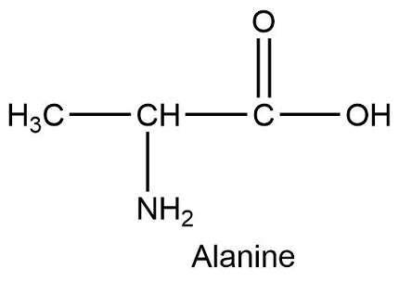
- How many sigma bonds are present in the compound below?
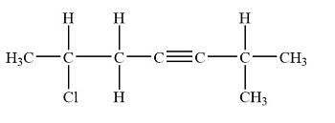

- What is the difference between paramagnetic and diamagnetic materials?

